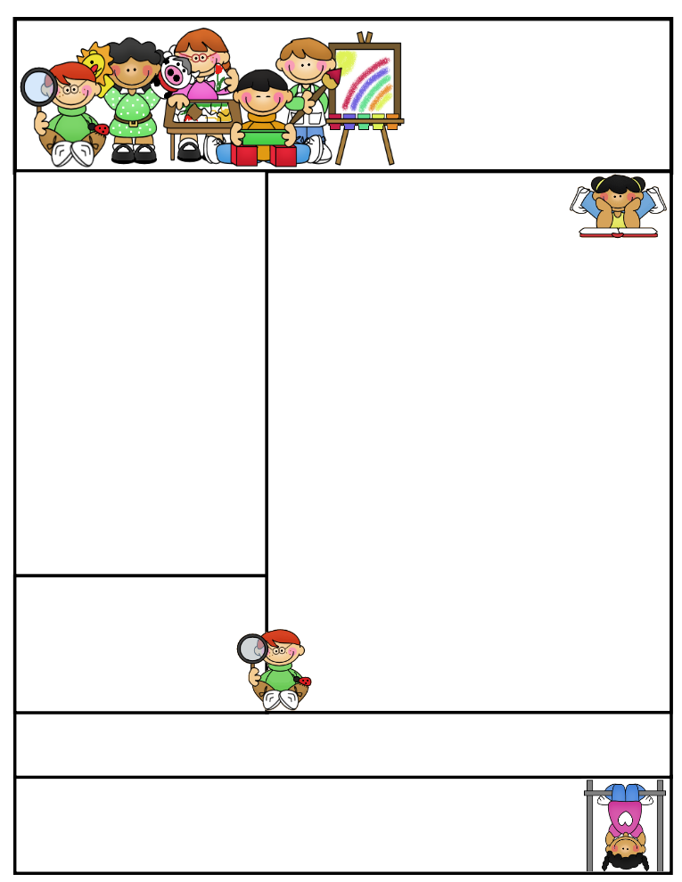

First Grade’s

Newsletter

December 5-December 9

2201 2014

Created by Ashley Magee Graphics © ThistleGirlDesigns.com

**Important Dates:**

12/6 Chic-fil-a biscuit sale $2.75

12/7 Early Release-2 hours early

12/8 Reading Family Night

12/20 Chic-fil-a biscuit sale $2.75

12/20 Winter Holiday Party at 12:30

12/21 Winter Break

1/5 Back to School

**Reminders:**

--Wednesdays are “Hat Day” for 50 cents. This is a fundraiser for Relay for Life.

--Fridays are “Ice Cream Friday” for $1.00

The deadline to order a yearbook for the **early bird special** pricing is December 20th.  After the New Year, the prices will increase.  The final deadline is March 13, 2017 for all yearbook sales.

Holiday Party

Our holiday party will be December 20th from 12:30-1:30, more information will be coming home soon.

**Helpful Tip for the Week**

**Play word games**

Have your child sound out the word as you change it from mat to fat to sat; from sat to sag to sap; and from sap to sip.

Classroom News

**Reading/ELA**

This week we will continue reading Charlie and the Chocolate Factory.

**Math**

This week’s focus will be measurement, time to the hour and half hour, and graphing.

**Writing**

Our focus will be how to write an opinion piece. We will continue to focus on features of sentences (capital letter, spacing, and punctuation.)

**Social Studies/Science**

We will complete our unit on famous Americans. We will begin to learn about light and shadows.

***Homework:***

***Math HW:*** *grid of problems (DUE FRIDAY)*

***Reading:*** *Reading with adult or MyOn for at least 15 minutes. Please use* [*w*ww.c**lever.com/in/pcsd**](http://www.clever.com/in/pcsd)*to log into MyOn.*

***Phonics****- Study your words each night. The words are located on a separate paper this week.*